Lab Integration

Discover/Requirements document

| Revisions | | | | | |
| --- | --- | --- | --- | --- | --- |
| Ver | Change Description | Sections | Date | Author | Reviewers |
| 0.1 | Initial draft | All | 12/12/2022 | *Isobel Jones* | *SG* |

# Project

## Document introduction

This document outlines the current state for In-House and External lab requests from Merlin. This document will capture the current ‘As Is’ process for lab requests, business analysis and requirements. This document will support the new ‘Lab Integration’ design and align to the business objectives.

These requirements have been driven from an important independent client that can no longer use the lab integration feature therefore highly impacting their operational processes which could lead to a loss of the business.

## Background

A vet may require further investigation on a patient by requesting a lab test. A practice will send the request to their preferred laboratory for them to process. Once the lab request has been processed a practice will receive the lab results for diagnosis or further investigation.

For core PMS (Merlin) we can no longer send lab requests to Idexx reference labs due to Idexx no longer supporting the integration (VetEnvoy) with Merlin. Therefore, practices that use Idexx for their preferred laboratory can no longer send requests automatically from Merlin and can no longer automatically import the results. This is leading to inefficiencies in the practice operation with manual data entry required, manual errors, incorrect results and delays.

Some practices also use In-House Idexx lab equipment which the automatic In-House lab request has been impacted.

Other reference laboratories may use VetEnvoy for their integrations which we will need to identify these.

Practices that are affected by this change are using individual workarounds that work for their operational set up. In this document I have captured the current As Is processes for Rowan House Veterinary Clinic. Rowan House use Idexx for In-House lab requests and external requests.

## Business analysis brief

As part of this document, a Business Analysis Strategy will assist in what is required to support the requirements through to lab integration solution, testing and delivery.

Business Analysis Strategy for Lab Integration

Analysis Context

|  |  |
| --- | --- |
| Analysis | What is required |
| INVESTIGATE CURRENT SITUATION | Current state at Rowan House   * Use Cases- completed 01/12 * As Is process-completed 01/12 * Impacts 01/12   *Other practices (Do we need, depends on business objective Who?How?)*   * *As Is process* * *Issues* * *Use Cases* |
| ANALYSIS | Business Objectives   * Rowan House objectives completed 01/12 * *Other practices objectives* * *MWI objectives*   HL Requirements   * Rowan House completed 01/12 * *Other opportunities* |
| CONSIDERATIONS | Current solution (Initial HLD available)   * Identify Design with documentation- received 01/12 * Identify current implementation approach- received 01/12   LL requirements support- Supporting SME?  Sign offs- who?  Merlin & IVC projects- Mischarges project  Iteration 1 already in progress  Notification project in PET |
| REQUIREMENTS | Walkthrough of current As Is, Business objectives and HL requirements in Design review  LL Requirements gathering   * Rowan House * Other opportunities   To Be business processes mappings |

# Investigate Current Issue

**Rowan House – Current state**

The purpose of the Rowan House visit (1st December) was to capture the ‘As Is’ processes for the whole ‘Lab Request’ process so that we were able to identify the issues. We initially identified the different Use Cases so that we could map the ‘As Is’ processes appropriate for each.

**Use cases**

The below use cases have been identified within the lab request scenario. They involve separate activity, roles and workflow steps that are under the same HL process objectives ‘lab requests’

1. **External Lab requests**

|  |  |  |
| --- | --- | --- |
| **Actors** | **Systems** | **Workflow** |
| Vet  Nurse/Admin | Merlin  VetConnect+ | Request |

1. **In-House Lab requests**

|  |  |  |
| --- | --- | --- |
| **Actors** | **Systems** | **Workflow** |
| Vet  Nurse/Admin | Merlin  Idexx lab equipment | Request |

1. **External results**

|  |  |  |
| --- | --- | --- |
| **Actors** | **Systems** | **Workflow** |
| Vet  Reception | Merlin  VetConnect+  Outlook  Idexx External labs | Retrieval |

1. **In-House results**

|  |  |  |
| --- | --- | --- |
| **Actors** | **Systems** | **Workflow** |
| Vet | Merlin  Idexx lab equipment | Retrieval |

**As Is**

1. External lab Requests

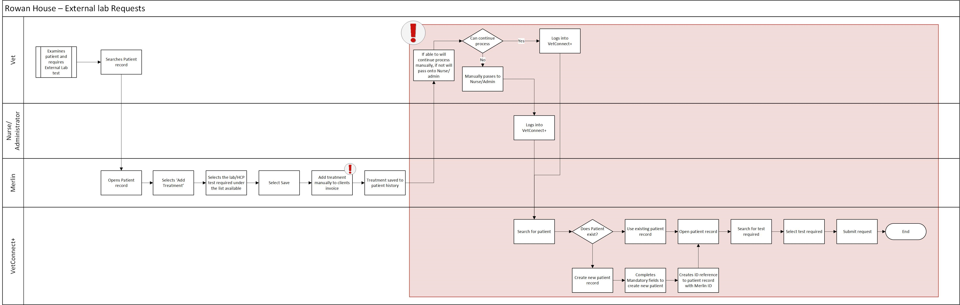

Pain points

* Adding payments manually to client invoices
* Manual data entry for requesting an external lab request

1. Internal lab Requests

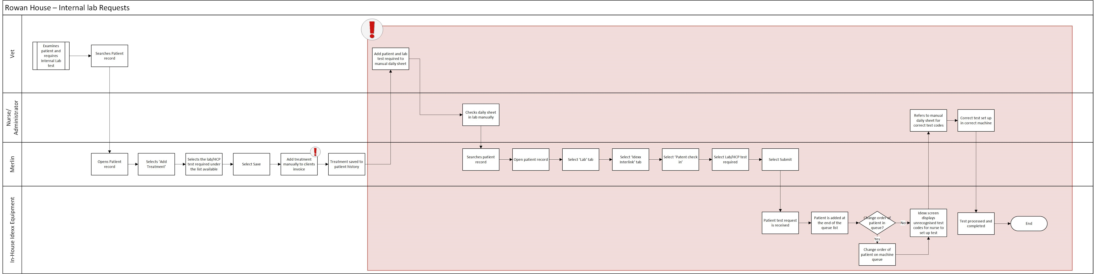

Pain points

* Adding payments manually to client invoices
* In-house equipment displays unrecognised lab test codes for lab tests when patient is checked in

1. External lab Results

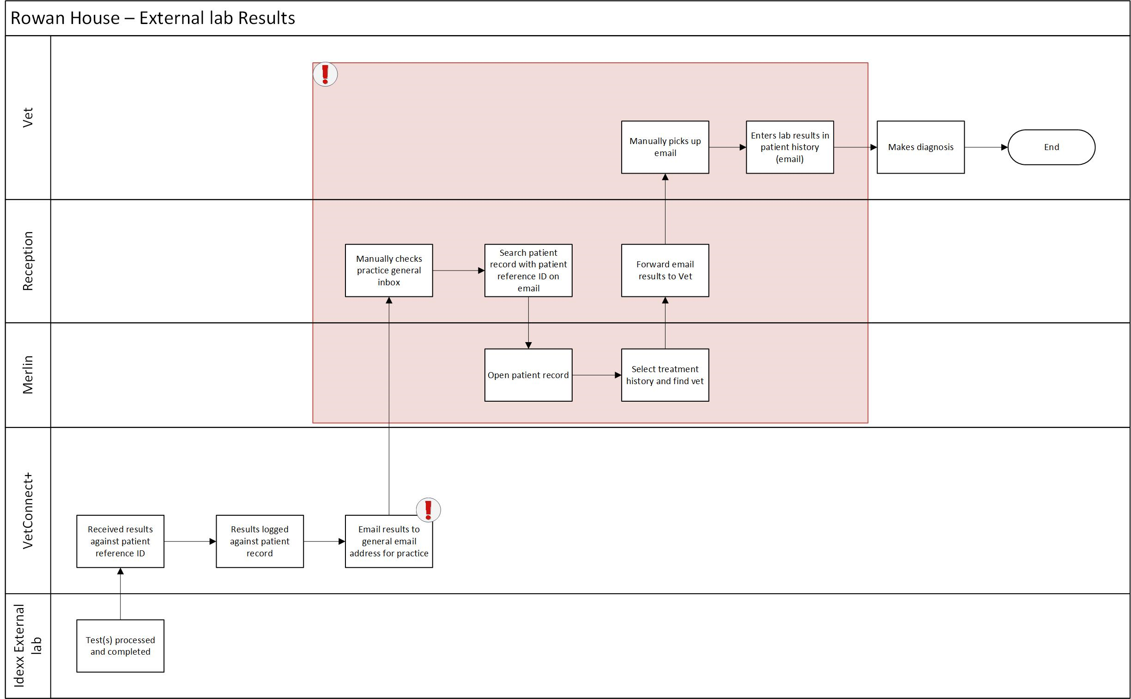

Pain points

* Results are sent to generic email address
* Results are not stored under patient record
* Not notified of results

1. internal lab Results

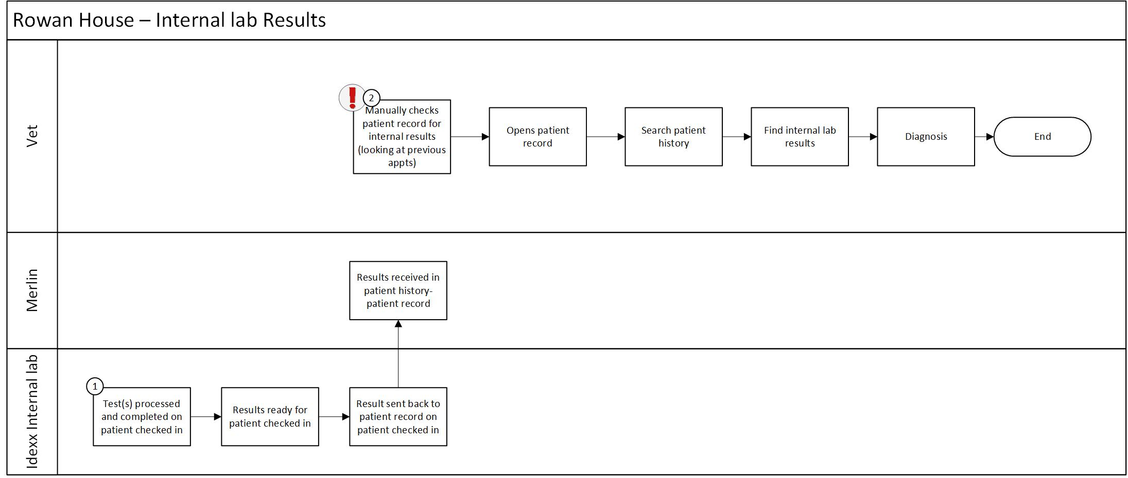

Pain points

* Not notified of results

**Rowan House -impacts**

* Delays in lab requests & lab results (external & internal) impacting operation and service of practice
* Mischarging clients resulting in cost and affecting reputation
* Missing auditability for compliance
* Operational inefficiency resulting in longer hours for staff
* Increased errors causing serious impact to patients

# Analysis

**Rowan House- Business Objectives**

**OPERATIONAL EFFICIENCY** - Increase effective use of resource by removing manual data entry

* *Removing manual data entry for external requests; 6 mins per lab request Ave. of 10-20 a day, saving manual effort between 60-120 mins a day (Source: Rowan House)*

**INTEGRATION** - Enhance timescales (turnaround times) of lab request and lab results without changing In-House lab equipment or preferred reference Lab

**COMPLIANT -** Clearer and confident audit trails by storing lab results immediately in patient records

**CUSTOMER EXCELLENCE** - Improved patient care with prompt result notifications

**ACCURACY** – Reduction in errors and duplication by creating an automated workflow

**Rowan House- High Level requirements**

|  |  |  |  |  |
| --- | --- | --- | --- | --- |
| HL ID | HL Requirements | HL Featured User story | Business objective(s) | MoSCoW |
| HLRLAB01 | As a vet (or qualified user) when I submit an external lab request this must automatically send to my preferred reference lab with attached mandatory patient information and lab test | **As a** Vet or qualified user  **I want** the ability to create an automatic external lab request against a patient  **So that** the correct request type, reference lab and correct tests have been requested | Operational Efficiency  Integration  Accuracy | M |
| HLRLAB02 | As a vet (or qualified user) when I submit an internal lab request this must automatically send to my In-House lab equipment with attached mandatory patient information and lab test | **As a** Vet or qualified user  **I want** the ability to create an automatic internal lab request against a patient  **So that** the correct request type and correct tests have been requested | Operational Efficiency  Integration  Accuracy | M |
| HLRLAB03 | As a vet (or qualified user) I want completed external & Internal lab results that I have previously requested to be received automatically and stored against the patients record | **As a** Vet or qualified user  **I want** to receive the external & Internal lab results received automatically and stored against the patient record  **So that** the results can be logged correctly and against the correct patient for diagnosis | Operational Efficiency  Integration  Accuracy  Compliant | M |
| HLRLAB05 | As a vet (or qualified user) I must receive a notification immediately when an Internal or External lab result has been received and stored against the patient record | **As a** Vet or qualified user  **I want** to be immediately notified when the External or In-House lab results have been received and stored against the patient record  **So that** I can efficiently diagnose and contact the client | Integration  Accuracy  Compliant  Customer excellence | M |
| HLRLAB06 | As a vet (or qualified user) I must have the ability to view and track all External and Internal lab requests | **As a** Vet or qualified user  **I want** to view the ‘Lab requests’ ordered  **So that** I can track progress on the ‘Lab requests’ | Accuracy  Compliant  Customer excellence | S |
| HLRLAB07 | As a vet (or qualified user) When I submit an external or internal lab request this must automatically apply the charge onto the client invoice | **As a** Vet or qualified user  **I want** the lab request charge automatically added to the client invoice when I submit an external or internal lab request  **So that** I can correctly charge the client | Accuracy  Compliant  Customer excellence | S |

# Considerations

**Current HLD**

There is currently an iterative approach for the external solution. The 3 stage approach initially start with sending Idexx requests through to VetConnect+. Iterative phases 2&3 include opens the request for all vendors

Iteration 1

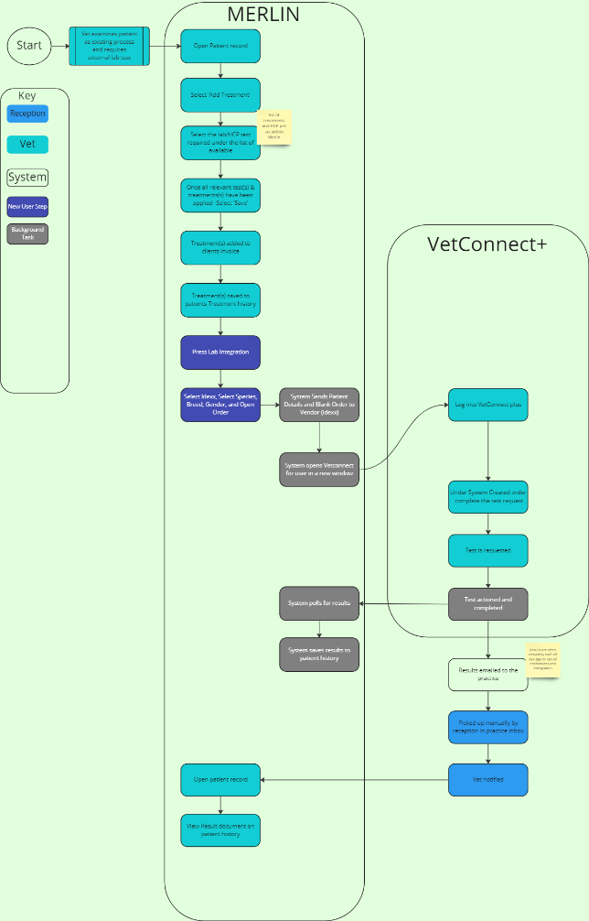

Iteration 2

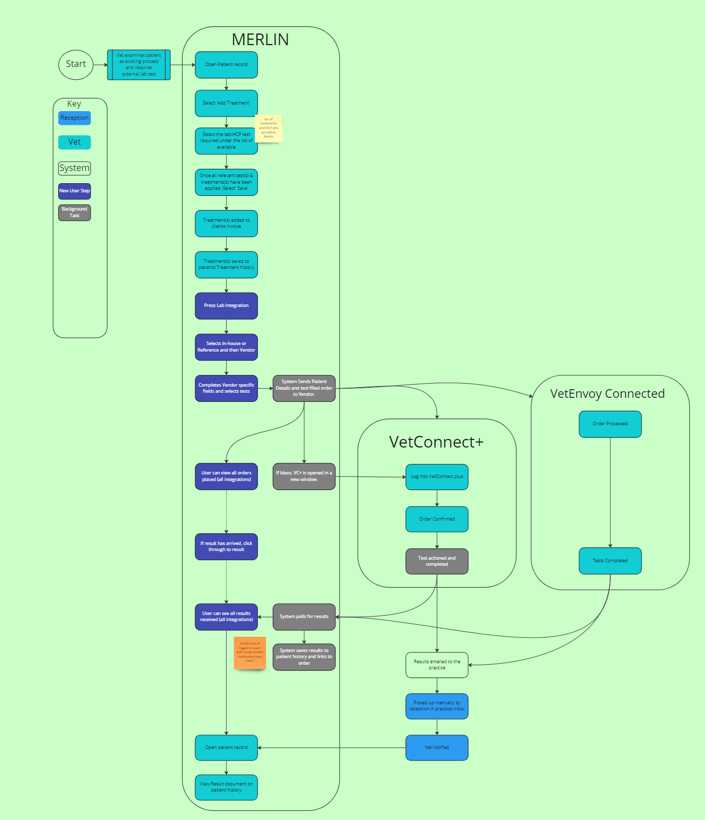

Iteration 3

